Data Loading

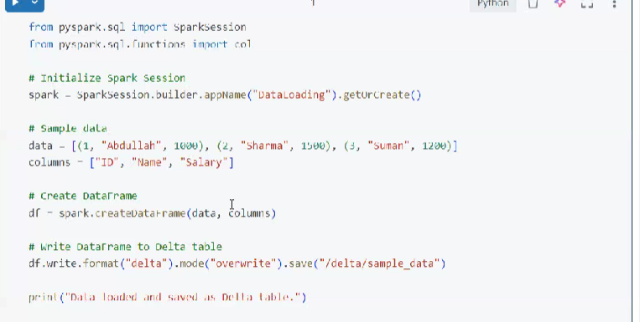

Data transform

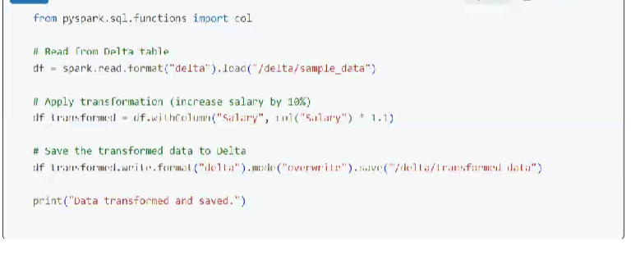

Data Analysis:

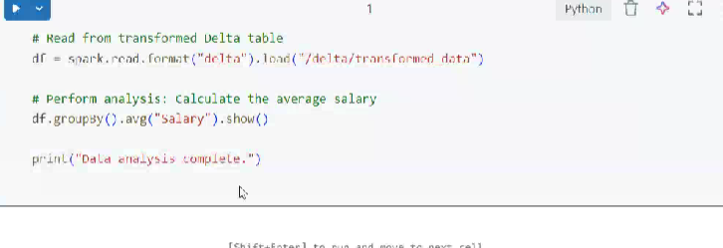

Data pipeline (Notebook Chaining)

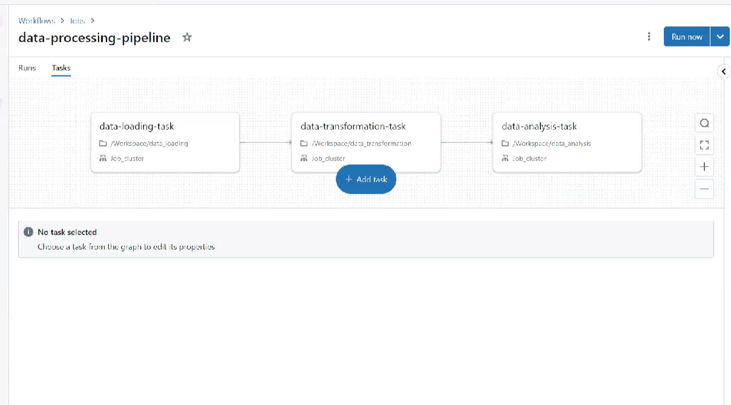

1. Create Different notebooks for different tasks
2. In the first notebook we create the task for data loading
3. The 2nd note book is dependent on the first one so we create a data transformation task
4. The 3rd notebook is dependent on the 2nd one, the transformed delta table can be accessed in the 3rd one
5. Now navigate to the Workflows and create a job and by “add task” we can link the notebooks to create a pipeline